Ethnographic Observation
Student’s Name
Institutional Affiliation

Ethnographic Observation
Secondary Research
Consumer behavior is a crucial topic in marketing. Consumer behavior is the analysis of various processes that consumers utilize to select, consume and dispose of goods and services (Trudel, 2019). Generally, consumer behavior encompasses the study of all activities that influence marketing. The other key aspects of consumer behavior include the attitude of the consumers, preferences, and their emotions. Marketers can only understand the consumers’ behavior by analyzing these aspects. It is important to understand consumer behavior due to varied reasons. One of the importance of studying consumer behavior is that it enables marketers to determine various factors that influence consumer's purchasing decisions. It is also vital to study consumer behavior to understand consumer’s expectations in the market. Through this initiative, the producers will be able to design products and services in a manner that corresponds to consumers’ needs. This is a better approach to enhancing the retention of consumers. The consumption behavior or patterns of the Chinese have changed faster over the years. One of the reasons for such changes is based on technological advancement and the role of technology in the lives of these individuals.
Chinese consumer demographics is one of the essential aspects of analysis. The main consumer force of Chinese are individuals between the age of 20 and 30 (Dudarenok, 2021). These individuals embrace heavy consumption of respective products and services in the market. These individuals purchase products and services that go beyond their needs. For instance, they are likely to purchase items for their parents and siblings. Therefore, there are diverse in their purchasing pattern.

The product variety is another important element of consideration when analyzing the consumer behavior of this cultural group. In the past, most Chinese emphasized price and function as core elements of considerations when purchasing products and services. Currently, these individuals have numerous issues to consider when purchasing varied items. Most Chinese focuses on the need to acquire high-quality products and services. This group aligns with premium products in the market since such items are of high quality (Dudarenok, 2021). Another aspect that influences their behavior is taste and preferences. Taste and preferences play a great role in influencing this group's consumption pattern. It is important to note that members of these cultures are not attracted to general products and services. Therefore, only products and services that align with their taste and preferences will penetrate this market.
Another issue that influences Chinese consumer behavior is health. These individuals care more about their general well-being. They are more health conscious when making decisions to buy any product or service. Food safety is among the central issues in this culture. It means that consumers do not embrace products and services that compromise their health.
Economic status is another important factor that influences Chinese consumption behavior. Income distribution is a fundamental issue of analysis when it comes to the purchasing power of consumers. Just like any other culture, the Chinese community experiences income inequality. Some individuals earn higher incomes while others are from average families. Those earning higher incomes are able to purchase expensive brands or products (Dudarenok, 2021). Most of them consume both local and international brands. On the other hand, individuals with low incomes prefer cheaper and affordable brands that satisfy their needs.
Finally, Chinese consumption behavior is also influenced by market opinion. Market opinion and feedback involve the way other consumers in the market rates a given product or service. These cultural groups are keen when purchasing any item since they usually review these items and compares their ratings. They are likely to purchase products and services that most people support (Xu, Qian & Zhang, 2021). For instance, friends and families have a great say when it comes to their selection habits. This group can easily purchase products that are recommended by their friends and families. Therefore, social recommendation plays a great role as compared to traditional advertisements in this culture.
Interviews
The two interviews were conducted to identify various aspects with regard to consumers’ behavior. These interviews utilized an open-ended questionnaire. Some of the questions asked in these interviews include:
What influences your decision to purchase products and services?
Are you loyal to a specific provider?
Based on the above interview questions, it was apparent that these interviewees had related responses. In response to the question on factors influencing their decision to buy products and services, both interviewees cited the spread of COVID-19. These individuals were laid off due to COVID-19. Therefore, they have been surviving on savings and support from the federal government (the stimulus package) as well as support from other family members and well-wishers. Therefore, income plays a crucial role in their consumption pattern because they can only buy products and services that are affordable. Similarly, they cited that they are only loyal to businesses that provide high-quality products. They argued that they are able to buy high-quality products even when the prices charged are high. For the sake of confidentiality, the interviewees requested me not to share their personal information and images in public. Therefore, I agreed to uphold this request since it is part of research ethics.
Participant Observation
I was privileged to participate in some activities with my interviewees from this cultural group. I accompanied these participants to a restaurant that serves the traditional food of this group. Based on my experience, it is evident that this culture embraces diversity in its meals. For instance, the traditional food served in this restaurant adapted American taste even though they preserved Chinese culture. One of the key takeaways was that this culture prefers Asian leaf vegetables such as bok choy as part of their diet. I also learned that this community loves fresh seafood and meat. Almost every customer who came to this restaurant ordered specific seafood. It was also clear that this culture utilizes cooking styles such as pan-frying, stir-frying, and deep-frying. I think that this style was mainly influenced by American culture. Generally, I enjoyed participating in this activity since it increased my insight into the culture's diet. Indeed, it is important to study other cultures to identify how similar or different they are from our own cultures.
Photos of the Event
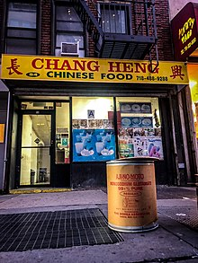

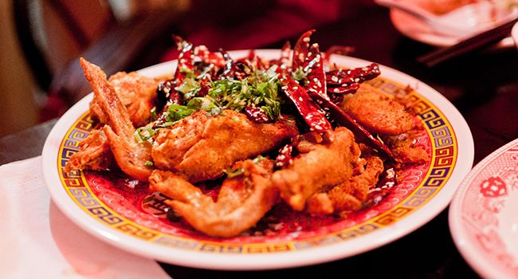

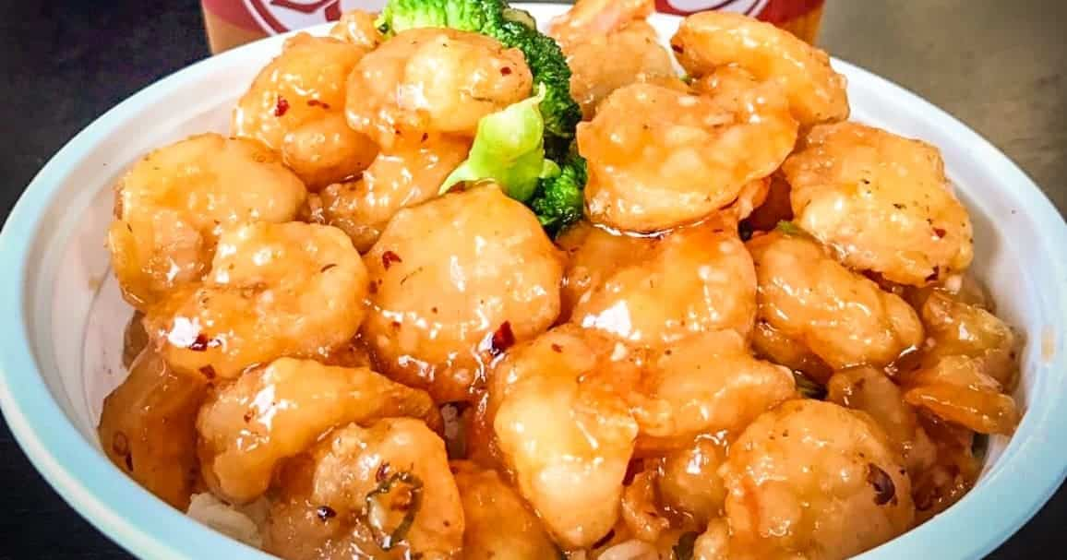



References
Dudarenok, A. (2021). Chinese Consumer Behavior Overview. Retrieved 7/28/2021. From https://chozan.co/chinese-consumer-behavior-overview/
Trudel, R. (2019). Sustainable consumer behavior. Consumer psychology review, 2(1), 85-96.
Xu, C., Qian, Z., & Zhang, Z. (2021, June). Analysis of Chinese Consumer Behavior on Catering Services and Research on Corporate Marketing Strategies in the Post-Pandemic Era. In 2021 International Conference on Enterprise Management and Economic Development (ICEMED 2021) (pp. 387-392). Atlantis Press.

